Input | patient’s Name  patient’s Age  patient’s ID
Process | Check patient’s name is not blank  heck age is between 1–150. Check fields are completed.  Check Patient ID is P + 3 digits and not duplicated.  Repeat if any input is invalid
Output | A message to ask the staff member to enter a patient’s basic details “enter patient’s details”  error message “Invalid input. Try again”  confirmation of the patient information "please confirm patient information"  "name: (name)"  "age: (age)"  "id: (ID)"  short success message "Patient registered successfully"
FLOWCHART
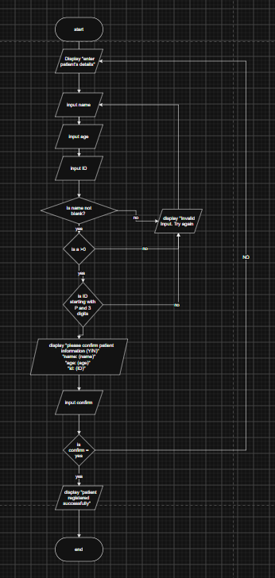

PSEUDOCODE
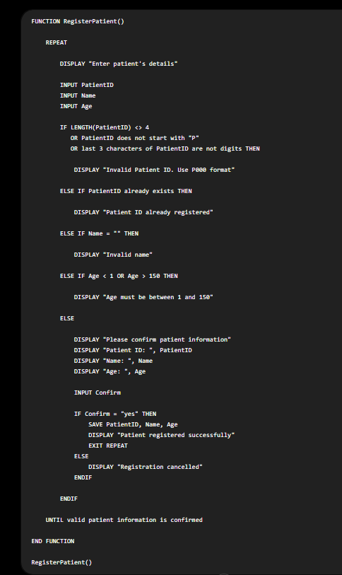

PYTHON
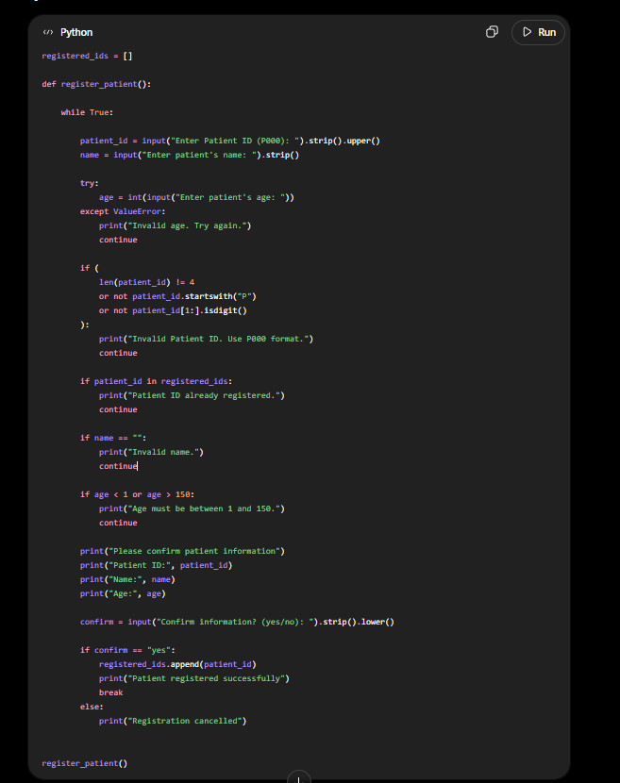
4. I used ChatGPT to help convert my flowchart and pseudocode into Python code. AI was also used to identify errors and improve input validation, such as checking for blank names, invalid ages, incorrect Patient ID length, and confirmation input.
5.
Prompt 1: “Check my IPO and make changes is needed”
Prompt 2: “check my flowchart”
Prompt 3: “turn the info on the flowchart in to pseudocode"
Prompt 4: “Turn this pseudocode into Python.”
Prompt 5: “Fix the code so it does not crash if letters are entered for age.”
Prompt 6: “Check and debug my final Python code.”

